**PATIENT DATASET | SURVIVAL ANALYTICS**

1. EventType – is the event occurred type .
2. FollowUp is the Time (t) ranging from 0 to 10

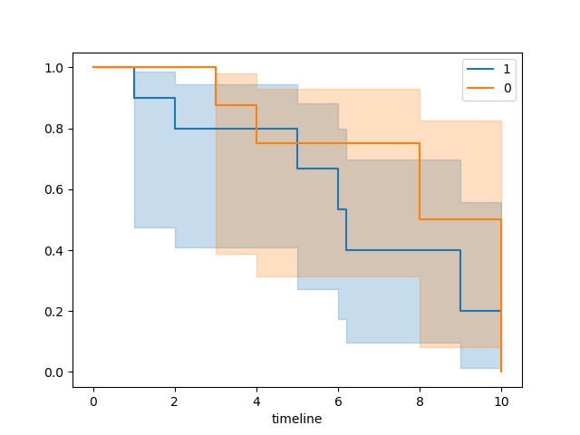

The Timeline indicates the total span of months that patients visited the clinic for a specific disease. All have same type of disease since all have Scenario A or some Stage in disease.

In the graph using Kaplan Miers Graph we see that the total Survival for orange line (0) No death occurred is good till 3 ½ month and after that there is an event or droppage of survival rate.

The Blue event might specify that death occurred and orange that patient did not die for that specific predetermined time (t).

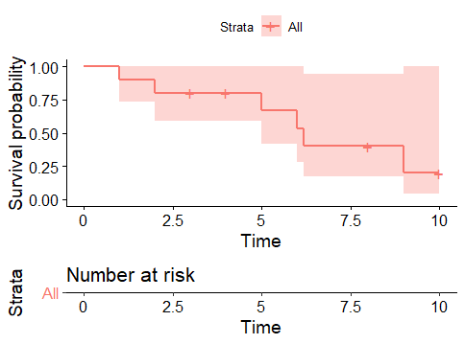

The + sign indicates here the CENSORING.

The patient either didn’t show up and no further studies was followed or patient was cured . (its Staggered data ) marked by X or +.

**The Life table presented below.**

time n_risk n_event n_censor sur_prob |

|-------------------------------------------|

| 1 1.0 10 1 0 0.9000000 |

| 2 2.0 9 1 0 0.8000000 |

| 3 3.0 8 0 1 0.8000000 |

| 4 4.0 7 0 1 0.8000000 |

| 5 5.0 6 1 0 0.6666667 |

| 6 6.0 5 1 0 0.5333333 |

| 7 6.2 4 1 0 0.4000000 |

| 8 8.0 3 0 1 0.4000000 |

| 9 9.0 2 1 0 0.2000000 |

| 10 10.0 1 0 1 0.2000000 |